**3D Plane Ride**

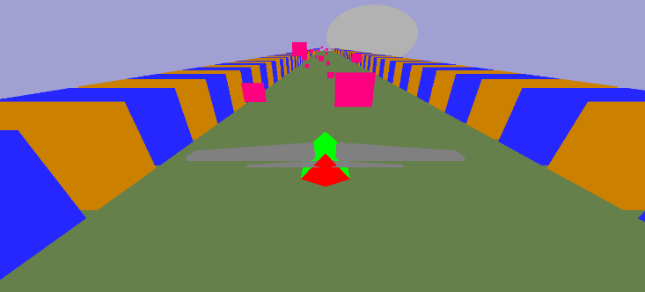

**Objective:**

This is a 3D plane game where you control a plane and fly through the sky while avoiding obstacles in front of you. You can achieve this by multiple of ways. Also you can change the camera position to your liking to have the best experience of this game.

**Environment:**

As you can see from the picture above, the plane is made by using multiple of shapes, and also there is a border of Orange & blue to limit the planes movement. The obstacles are given as pink rectangles. And the last feature of the environment is that it gives a day/night feelings.

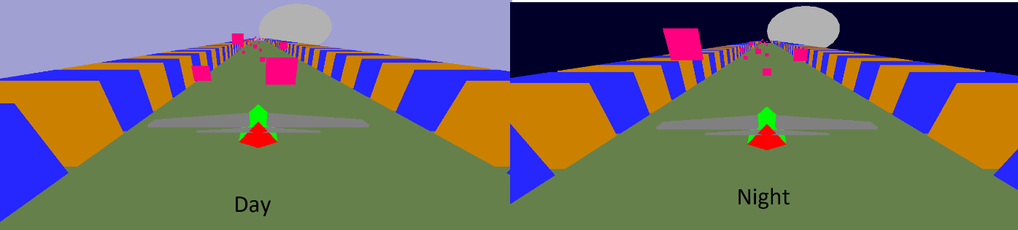

**Features:**

1. Day/night environment.
2. Multiple obstacle to avoid
3. Multiple ways to steer the plane
4. Position reset after lifting up keys
5. Different ways to change camera position
6. Clash with obstacles can be detected

**Instruction:**

You can directly play the game without any menu. This is made in such a way that people from all ages would get a hang of this. The plane can move within a certain limit so that the environment doesn’t look odd. The keyboard control is given below-

|  |  |
| --- | --- |
| **KEY** | **Description** |
| 3/4/5/6 | Rotating camera angles |
| Up/Down/Left/Right | Moving camera angle |
| W/S/A/D | Rotating plane while also moving on that angle |
| Q/E/R | Moving plane without rotating |
| Lifting key from W/S/A/D | Reset plane position |

**Future Work:**

We have plans to make the game better than ever by adding more sky details while also throwing in coin with the obstacles to have a point system to make the game even more interesting, also some minor changes for the environment on the ground.

**Conclusion:**

By making this game, we learned a lot about how difficult even a simple game can be, since we have to have in mind what must stay in a game to get the people’s attention. I tried our best to make the game interesting, and beautiful. And we believe we achieved it.

